**Lakes of Kashmir**

This is a project about the placid subterranean lakes of the beautiful Jammu & Kashmir, there history and aquatic life will also be discussed.

**Introduction:**

In this project we’ll discuss some of the most prominent lakes of Jammu and Kashmir, India. We’ll come to know about there history, produce and aquatic life.

The two lakes which we’re going to discuss about are Dal Lake, Wular Lake and Mansar Lake:

**Dal Lake:**

Dal lake is the most famous lake of Jammu and Kashmir and one of the prominent tourist destinations of the region. The Srinagar city is built around this lake. There are two theories about the origin of this lake, one referring that it is a post-glacial lake while the other states that it was formed due to flood spillage from the Jhelum river. The Second largest lake of Jammu and Kashmir is spread over 18 square kilometers and has a shoreline of 15.5 kilometers. It is a warm monomictic lake. Natural wetlands and floating gardens make up the periphery of the lake. The floating gardens, known as “Rad” in Kashmiri which bloom with lotus flowers during July and August. This wetland is divided by causeways into four basins: Gagribal, Lokut Dal (means ‘Small Dal’), Bod Dal (means ‘Big Dal’) and Nigeen (Nigeen is also considered to be an independent lake). Lokut Dal (means ‘Small Dal’), Bod Dal (means ‘Big Dal’) each have an island in the centre, known as Rup Lank (or Char Chinar) and Sona Lank respectively.

There are various species of Flora and Fauna in the lake.

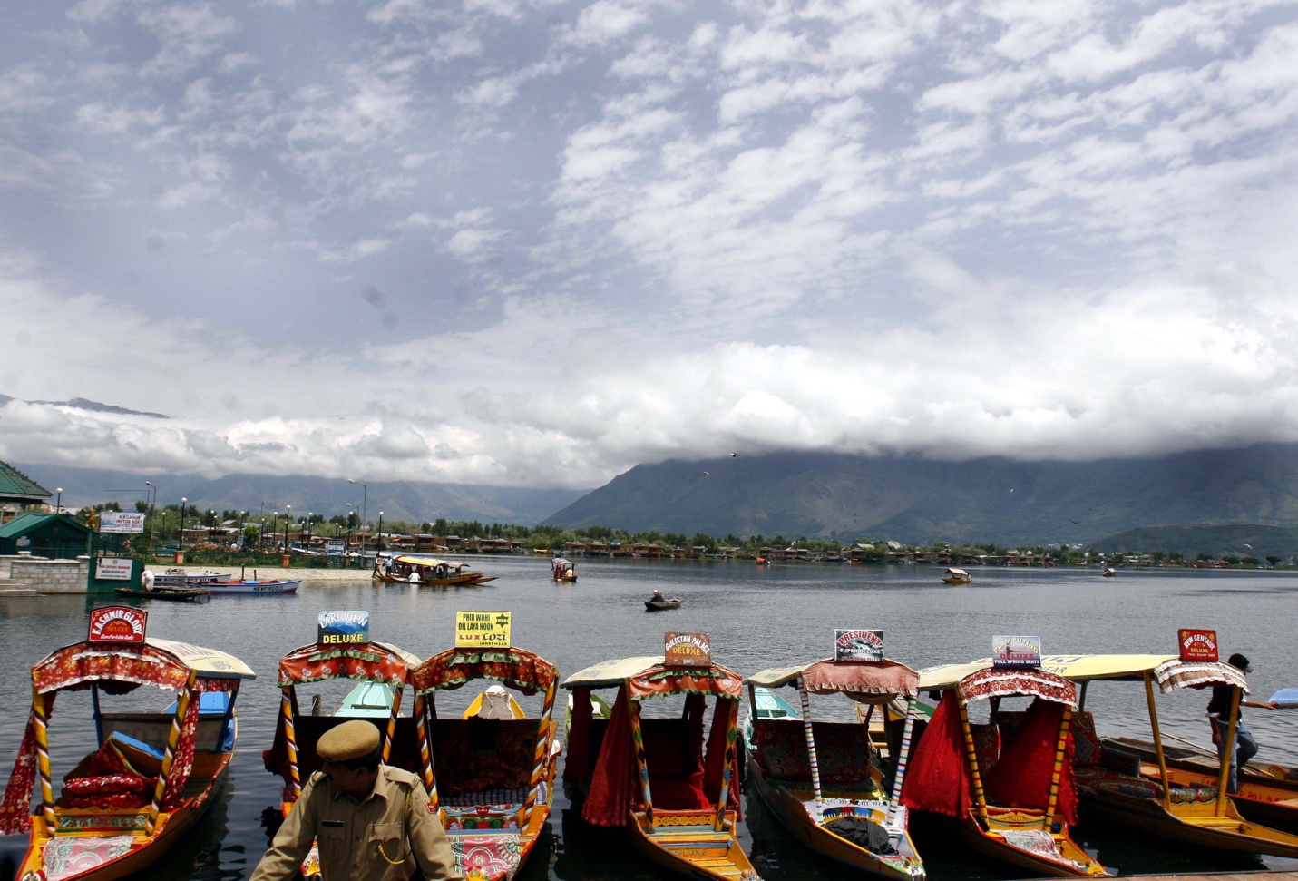

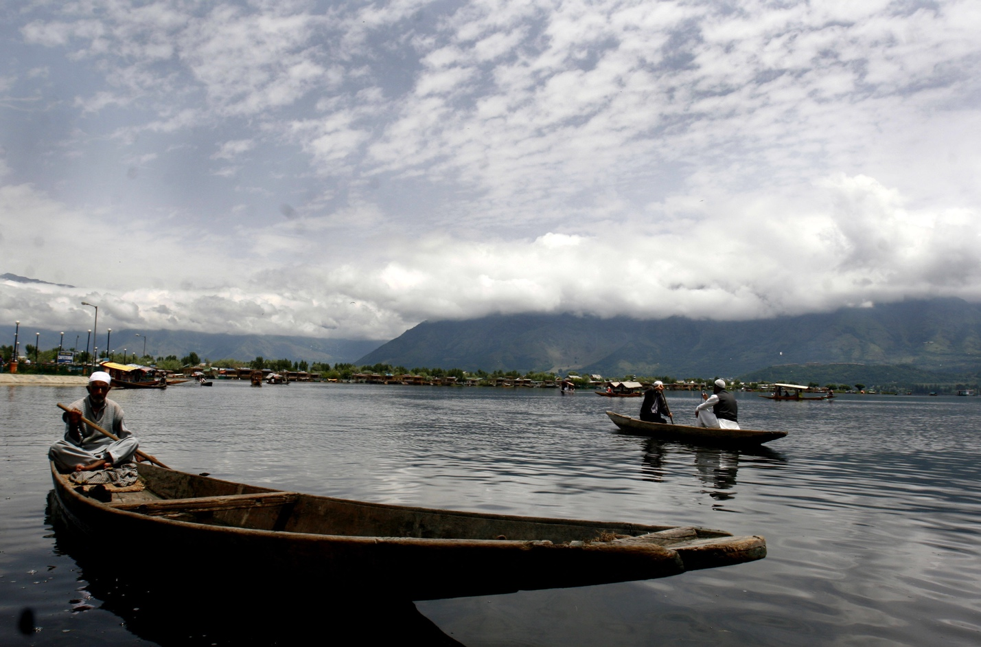

**Wular Lake:**

Wular Lake is one of the largest freshwater lakes in Asia. It is situated in Bandipora district of Jammu and Kashmir. The lake basin was formed as a result of tectonic activity and is fed by the Jhelum river. The lake’s size is approximately 189 square kilometers, it varies seasonally. There is also an artificial island constructed in the middle of the lake in 1444 named Zaina Lank. It also attracts many tourists because of it’s boating, water sports and water skiing opportunities.

There are many types of aquatic and aerial animals present in the lake.

